**Muhammad Abdullah**

**SE(4A) | 19F-0916**

Operating System

Installation of Ubuntu(linux) on Virtual Machine

**TASK # 1:**

**INSTALLATION OF UBUNTU**

**Phase 1: Downloading and Installing VMware**

**Step 1: Open Browser and Search VMware Player**

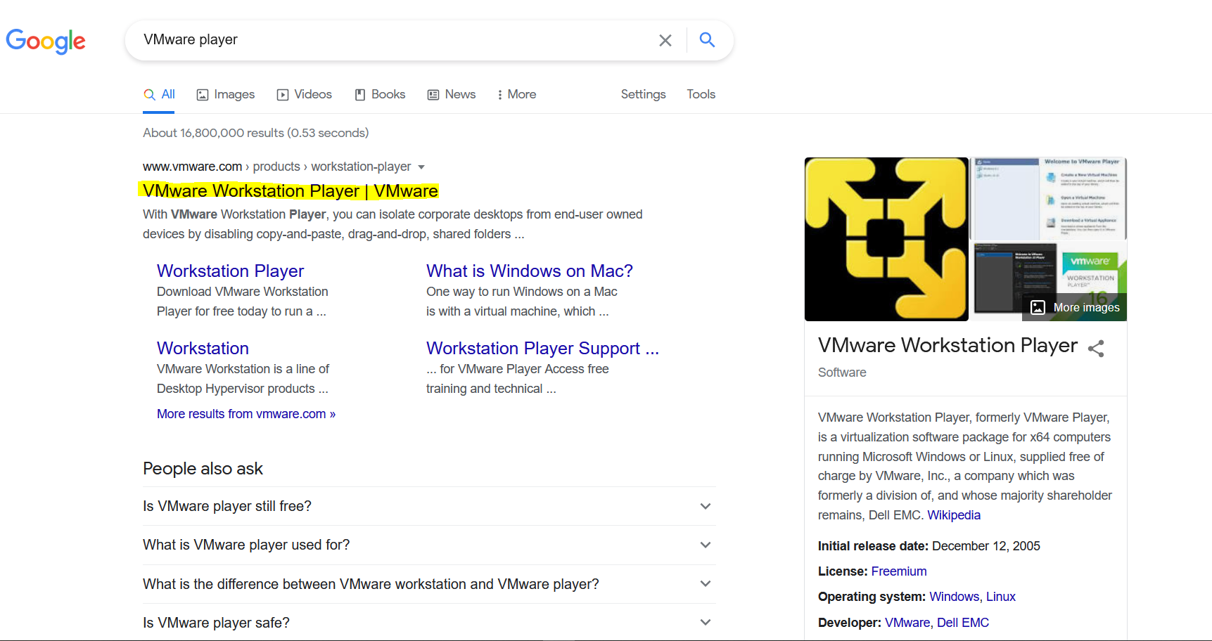

**Step 2: Click on Download Now as shown below:**

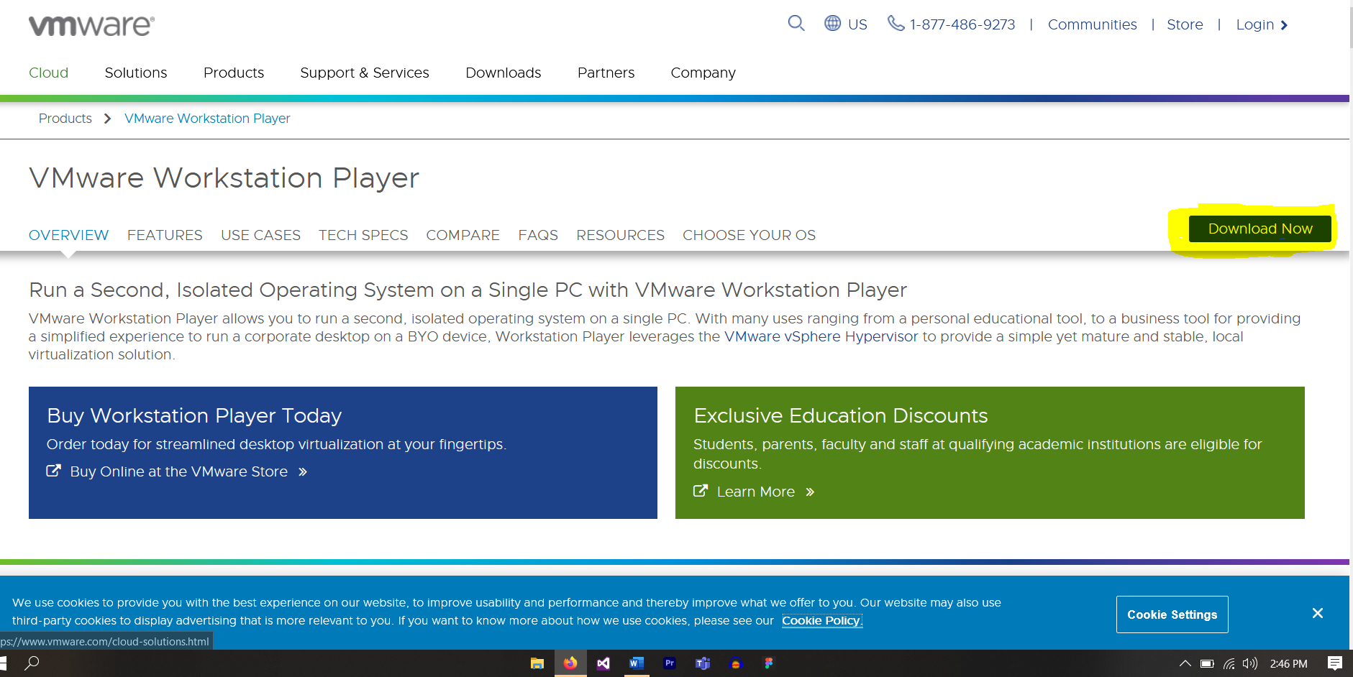

**Step 3: Click on Go to Download as shown below:**

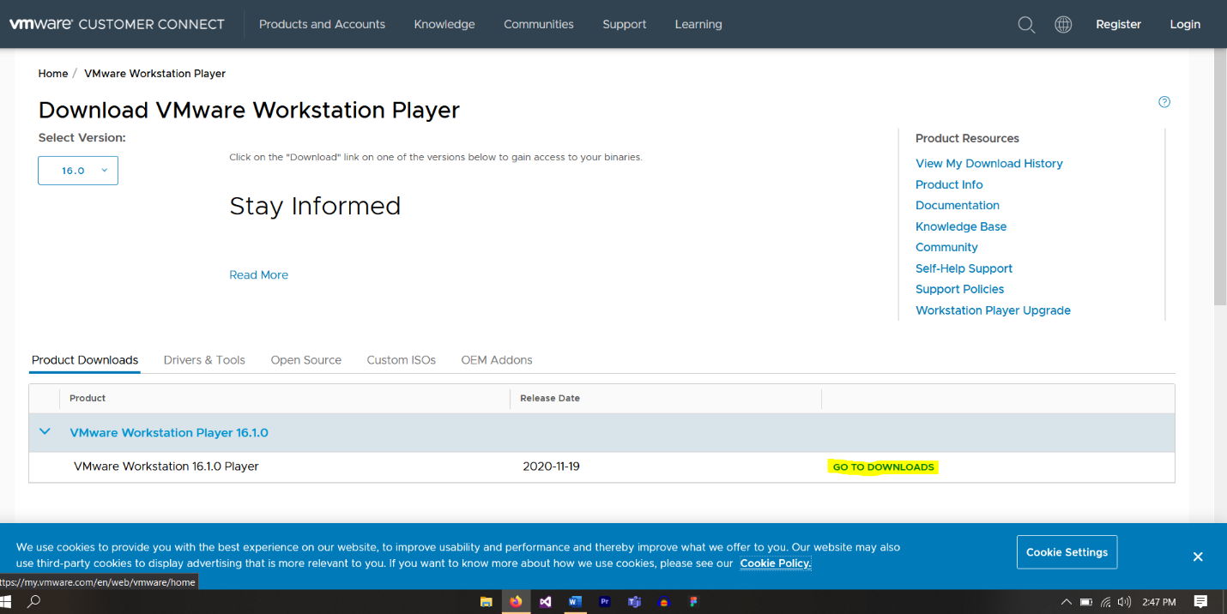

**Step 4: Click on Download Now to download VMware for Windows as shown below:**

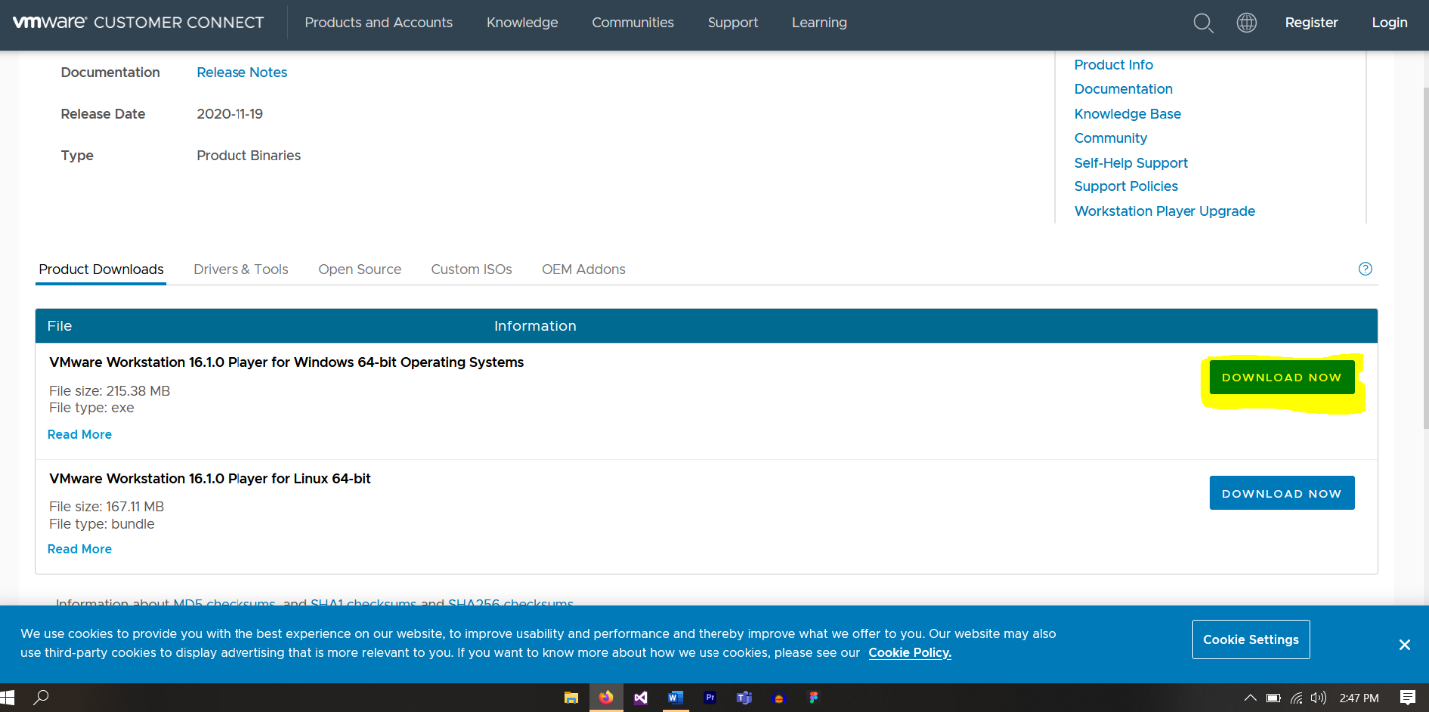

**Step 5: Press on save File and Downloading will begin.**

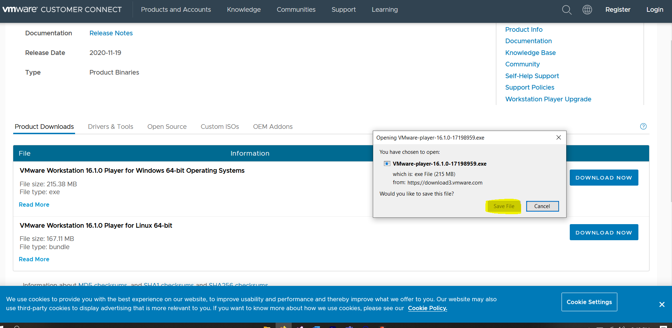

**Step 6: Double Click the downloaded VMware Player File to open it.**



**Step 7: Click Next to Proceed**

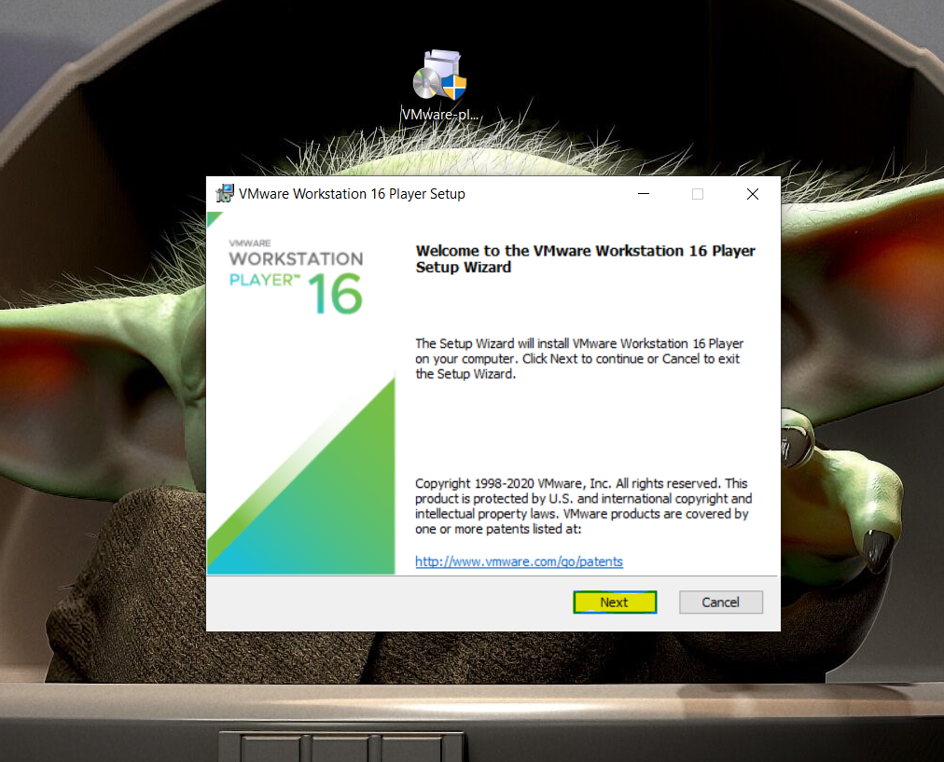

**Step 8: If you want to give custom path, select Change to install VMware wherever you want. By default, it is set on C drive.**

**Choose the option shown below and click next to proceed.**

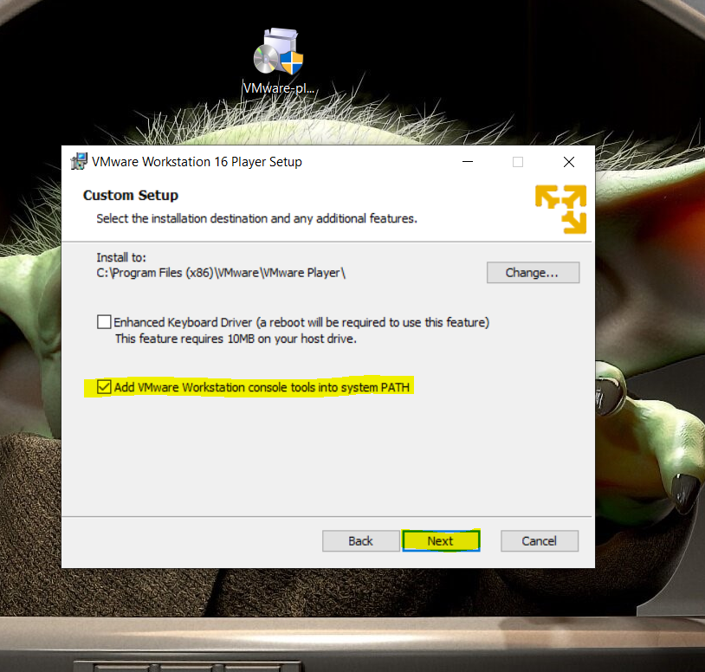

**Step 9: If you want to permit VMware to check for updates on startup then you can check the 1st box or you can simply press next to Proceed.**

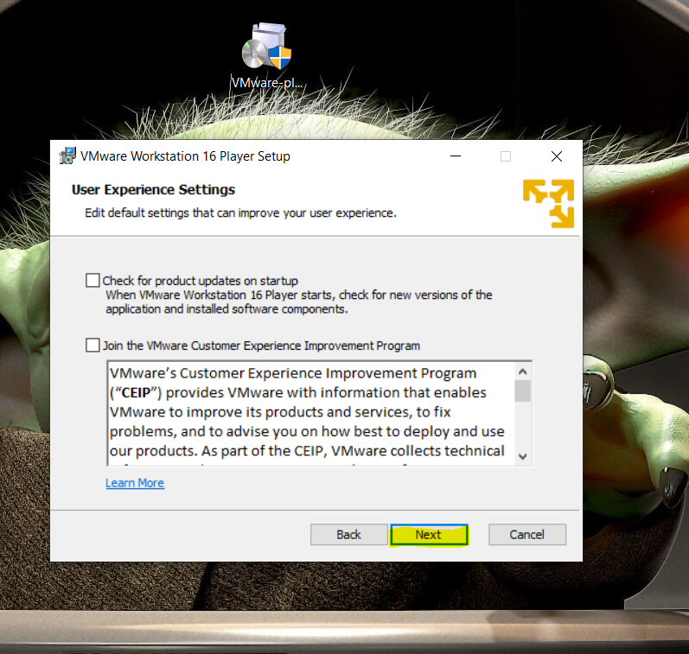

**Step 10: If you want to make a shortcut on desktop then select 1st box or click Next to Proceed.**

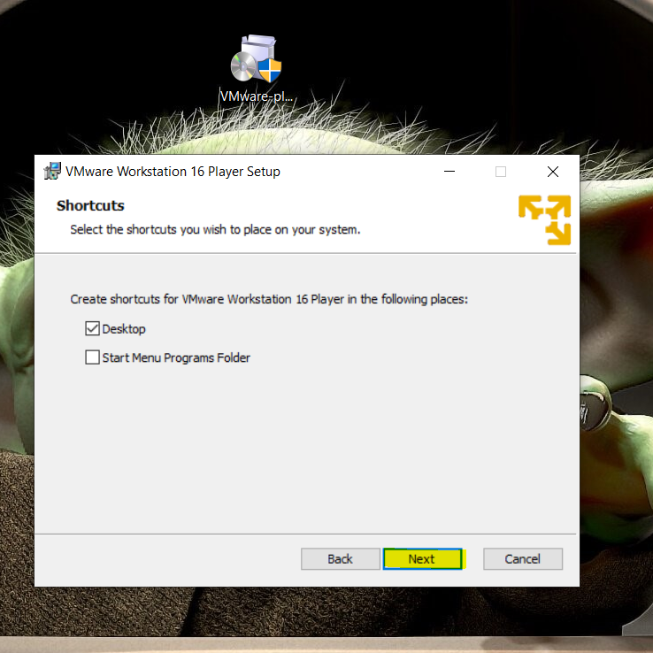

**Step 11: Now press Install to install the VMware in the system.**

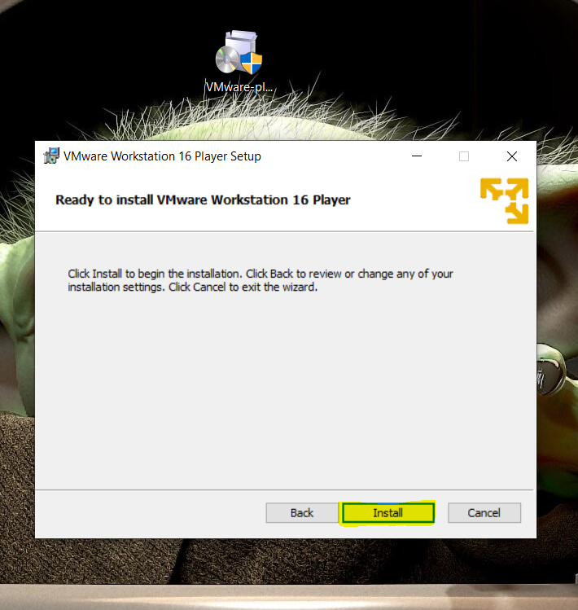

**Step 12: At the end, press Finish to finish the installation.**

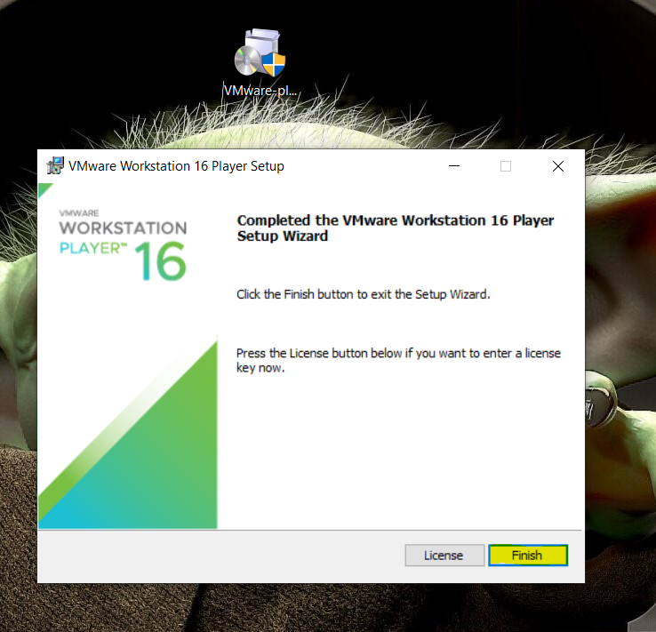

**Step 13: Open VMware from desktop and Choose the Option as shown below and press Continue then press Finish to complete the configuration of VMware player.**

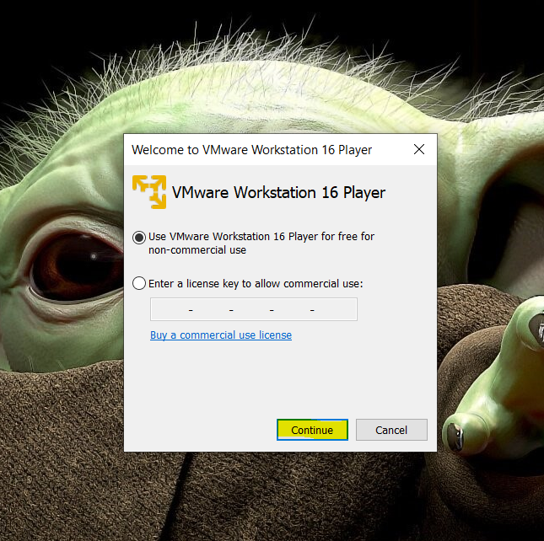

**Phase 2: Downloading and Installing Ubuntu**

**Step 1: Open Browser and Search Ubuntu and Select Download as shown below:**

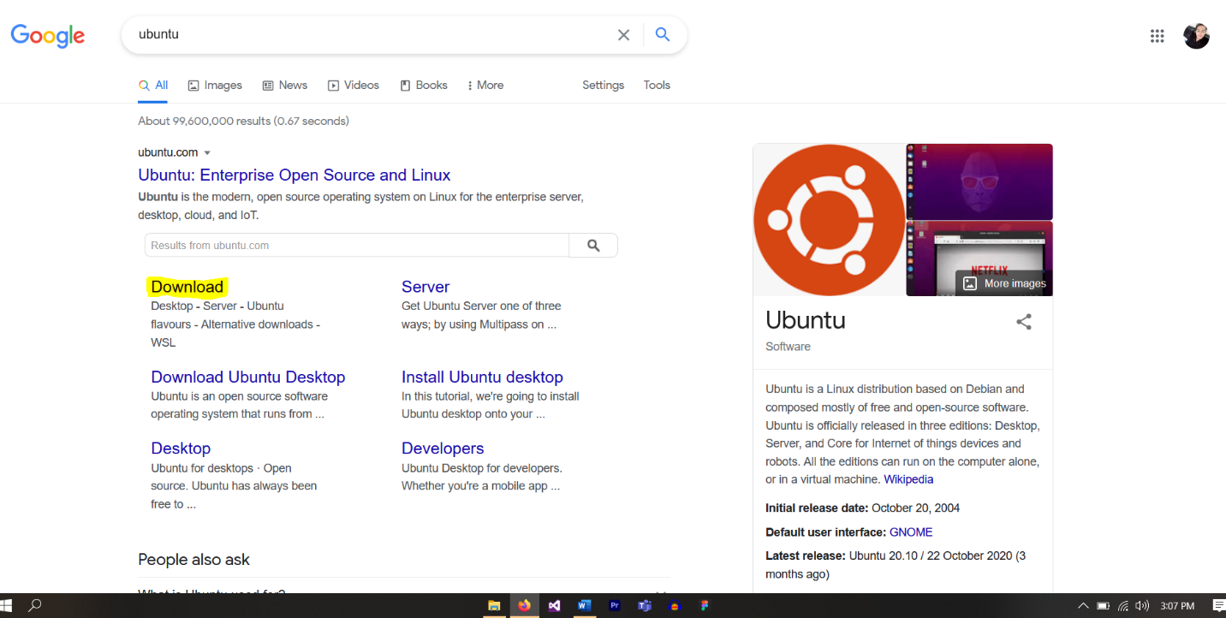

**Step 2: Select Desktop from the Menu Tab as shown below:**

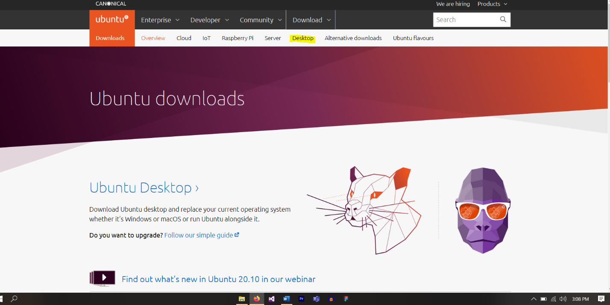

**Step 3: Click on Download to download latest Ubuntu version.**

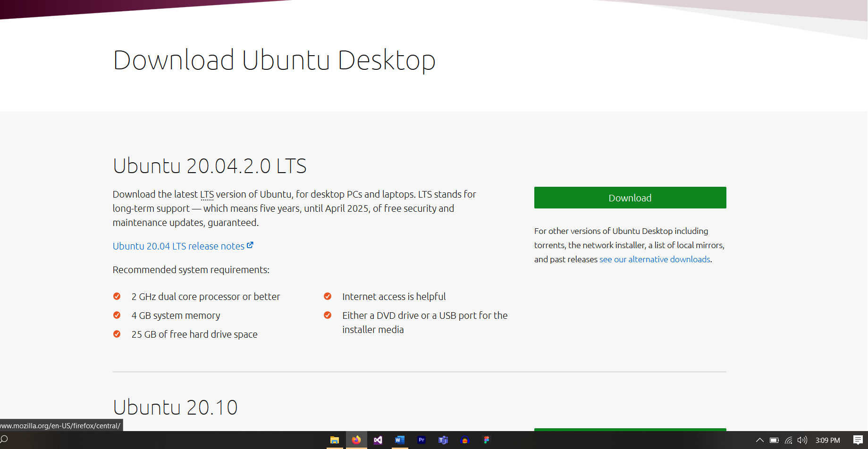

**Step 4: Wait till downloading gets started then press Save File to start downloading the Ubuntu.**

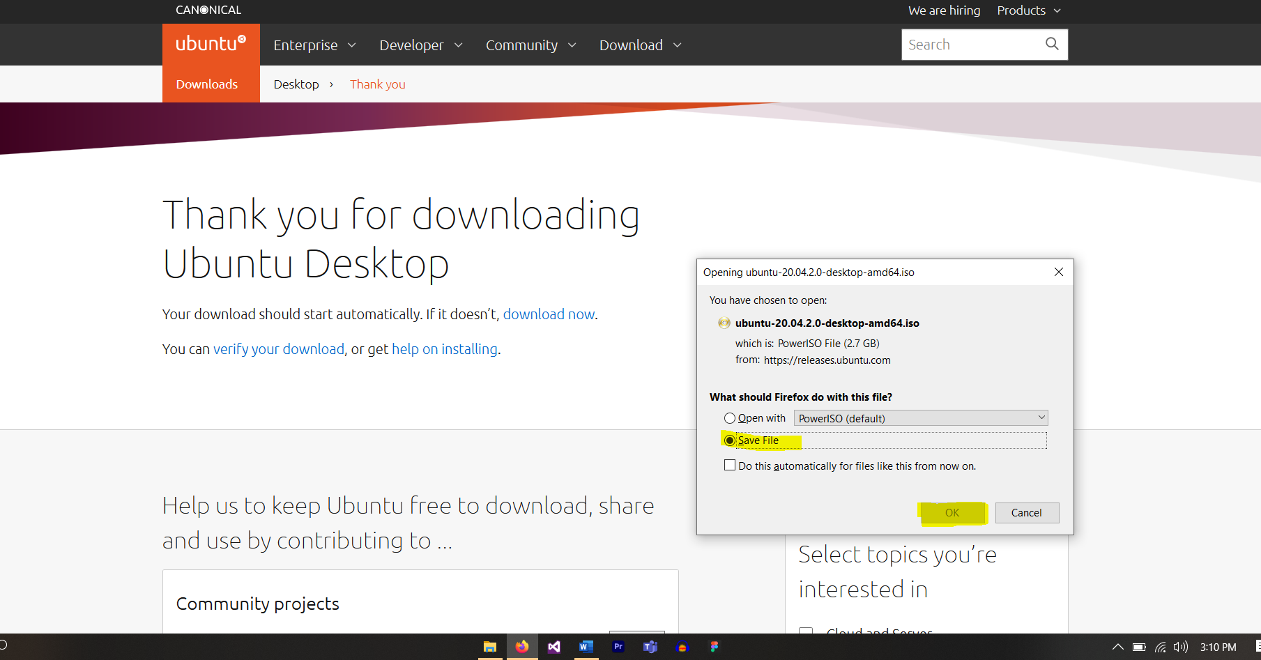

**Step 5: Wait till downloading gets completed.**

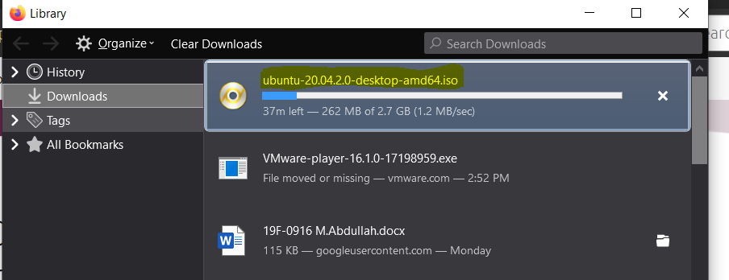

**Step 6: Open VMware and click on Create a New Virtual Machine as shown below.**

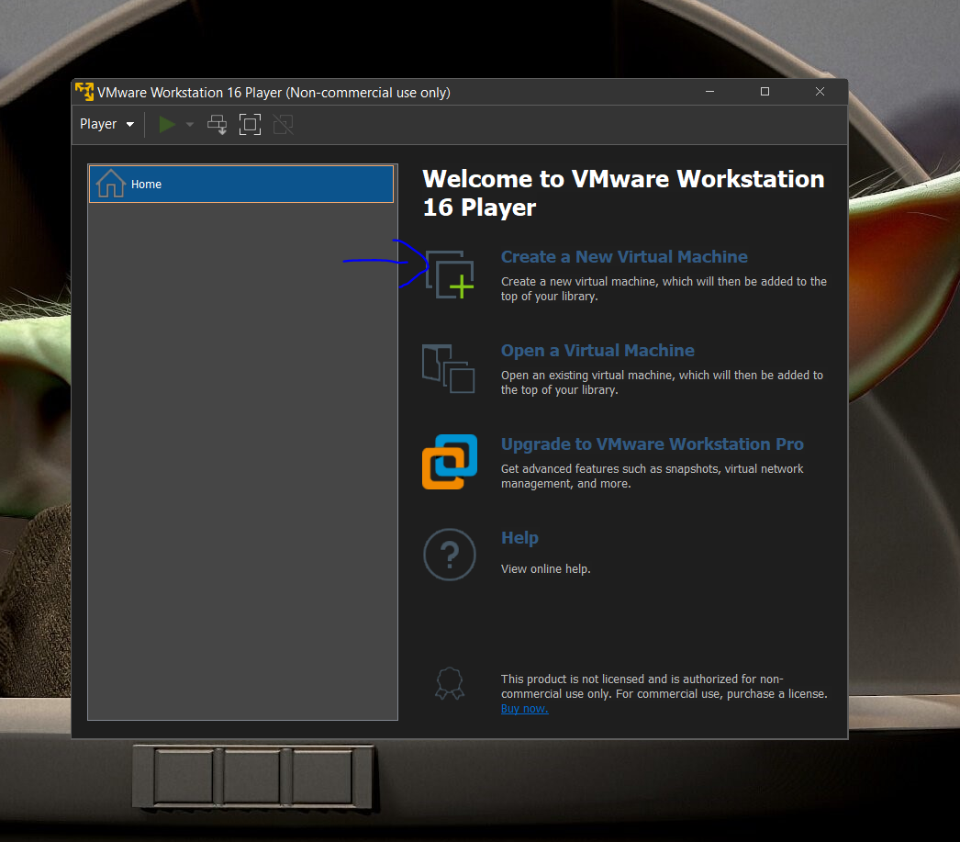

**Step 7: Click on Installer Disc Image File (ISO) to select the image file that we have downloaded earlier as for Ubuntu**

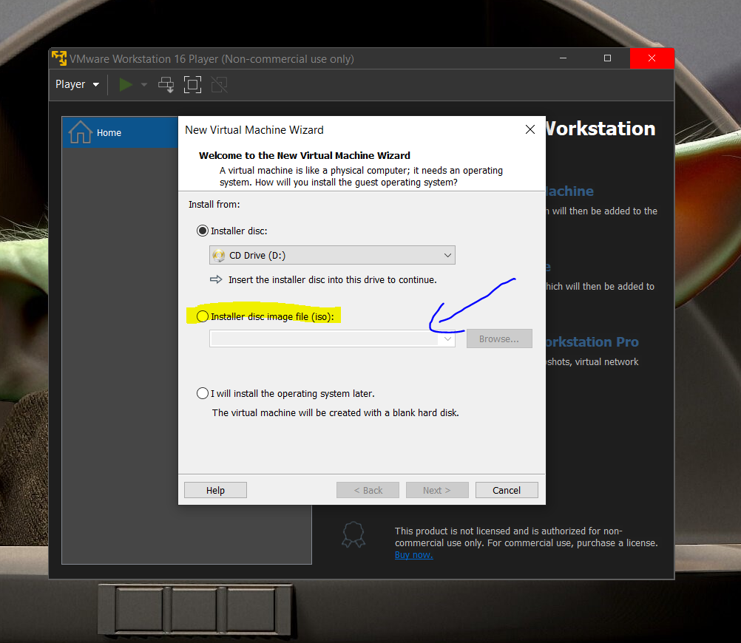

**Step 8: Click on Browse to select the location where you have downloaded the Ubuntu Image File**

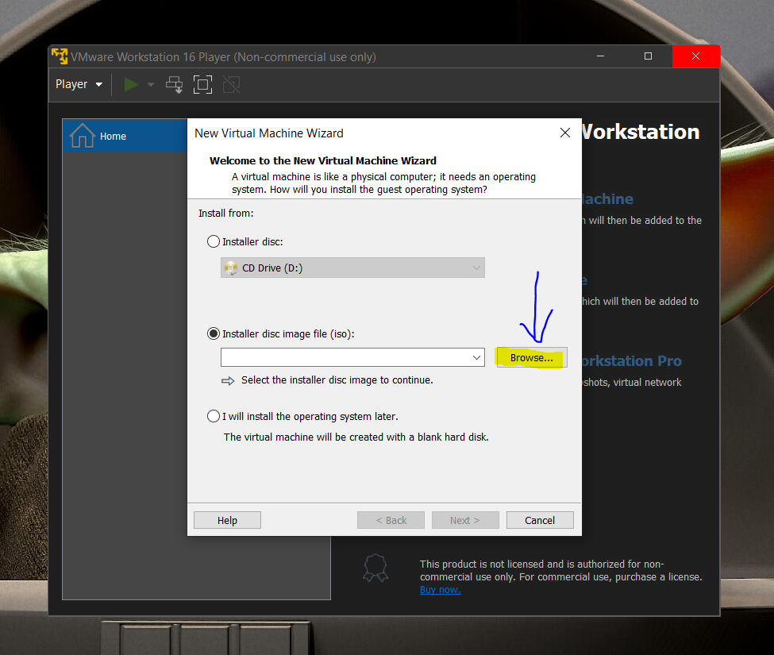

**Step 9: This is how it will look after you have selected the Ubuntu Image File that have been downloaded before.**

**Click Next to proceed.**

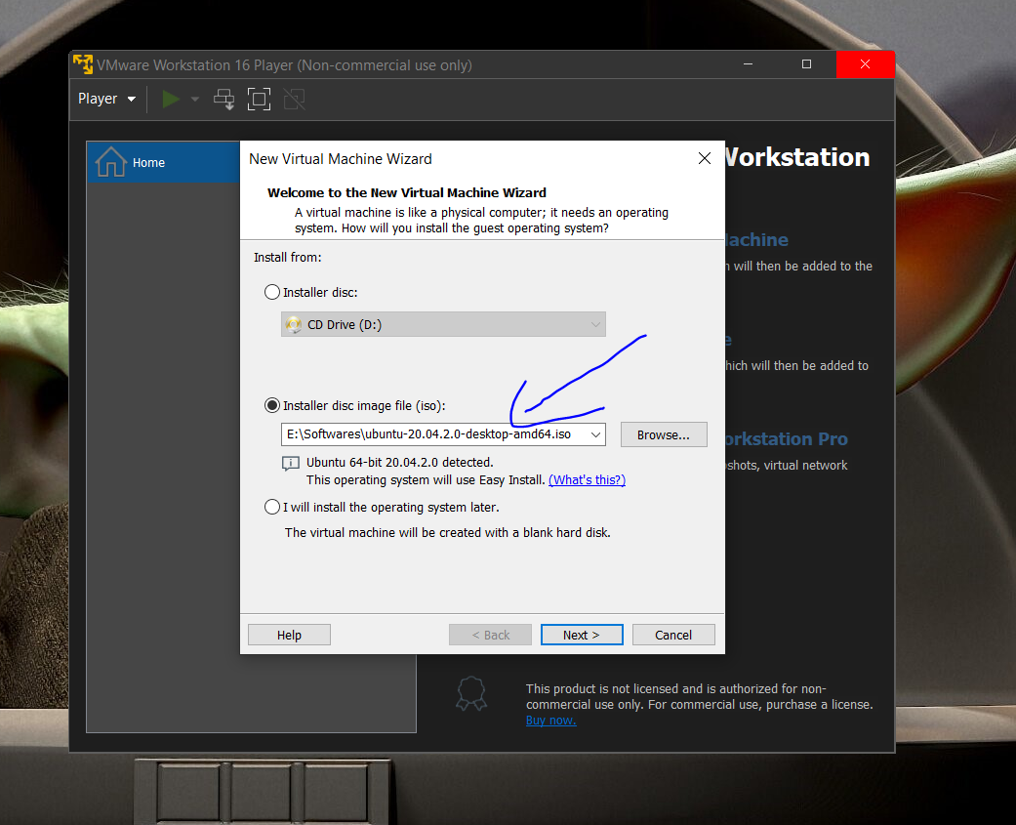

**Step 10: Enter your credentials here.**

**Enter name and password in the respected blocks then click on Next to Proceed.**

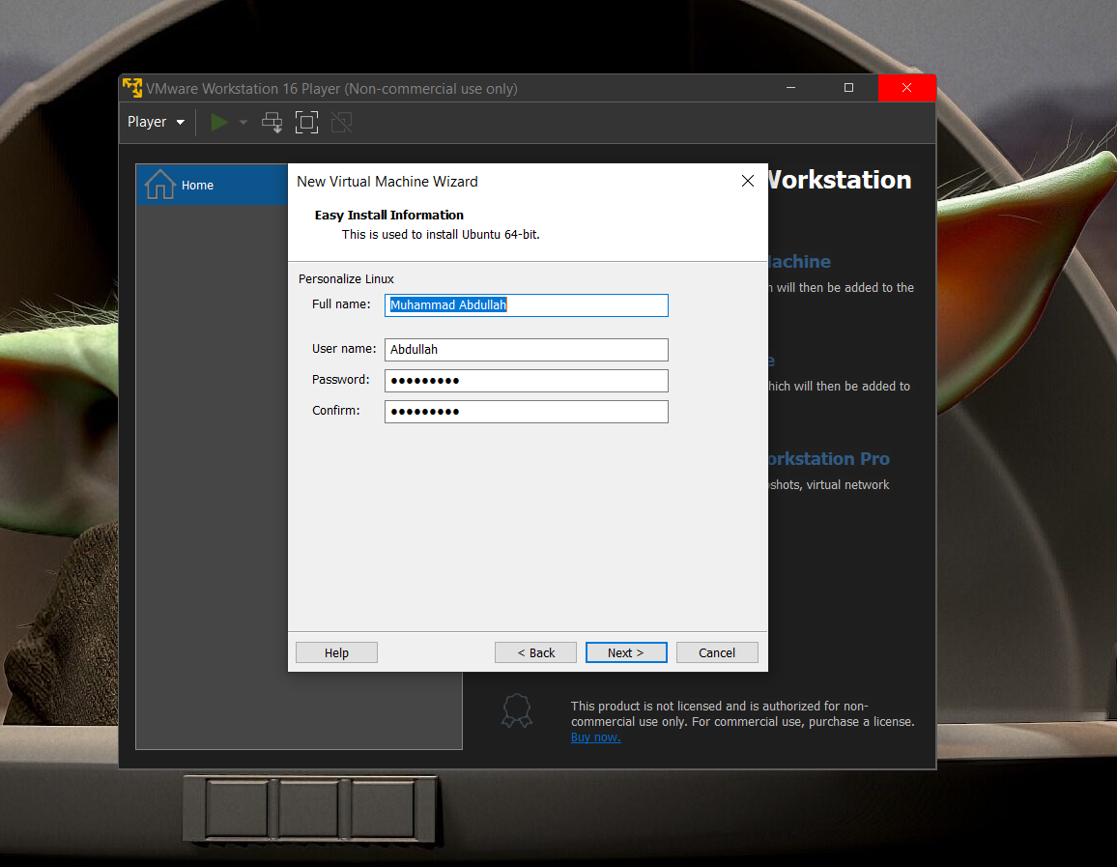

**Step 11: Choose the Virtual Machine Name to give any name to your machine Then Choose the location where you want to install Ubuntu by clicking in Browse.**

**After that, Click on Next to Proceed.**

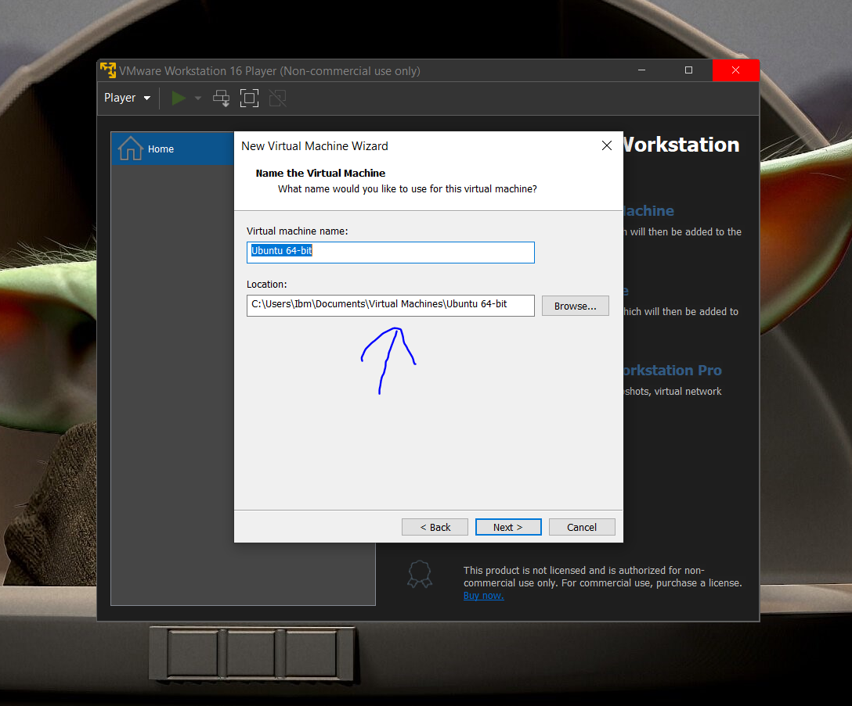

**Step 12: Give the maximum size that you want to allocate for Ubuntu in the Maximum disk size tab.**

**Then press next to proceed.**

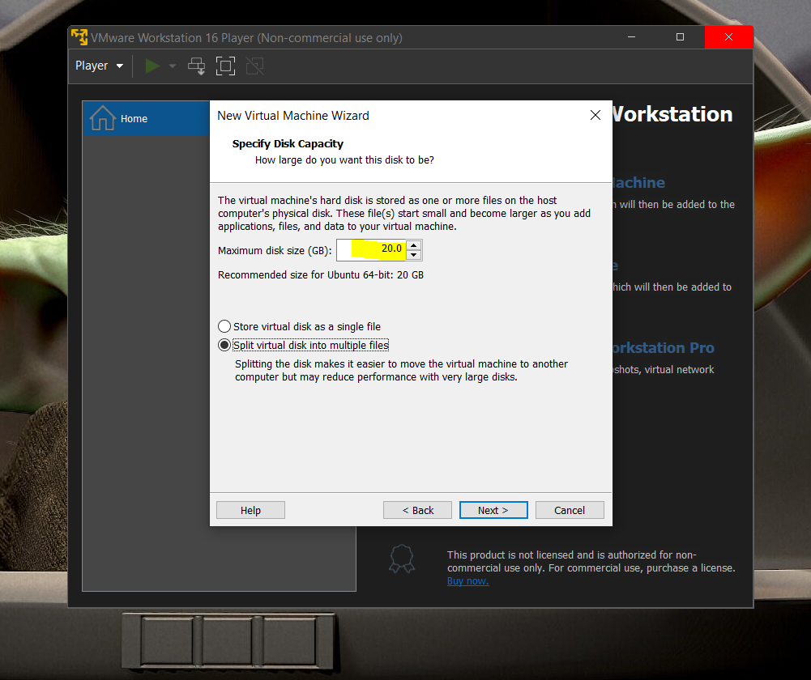

**Step 13: After everything is done, Press Finish to start the installation of Ubuntu on VMware.**

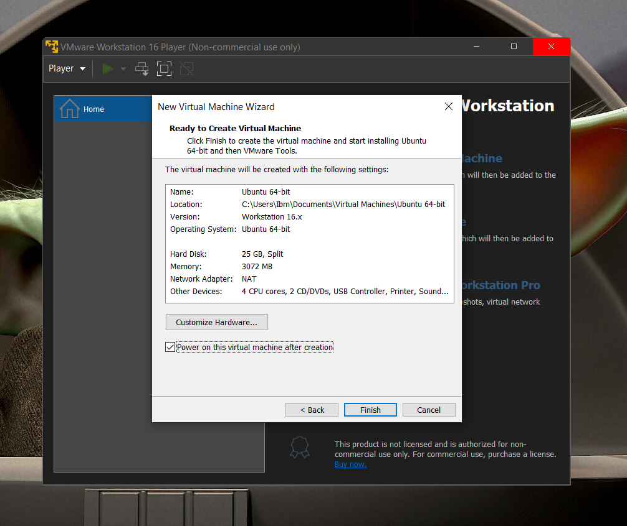

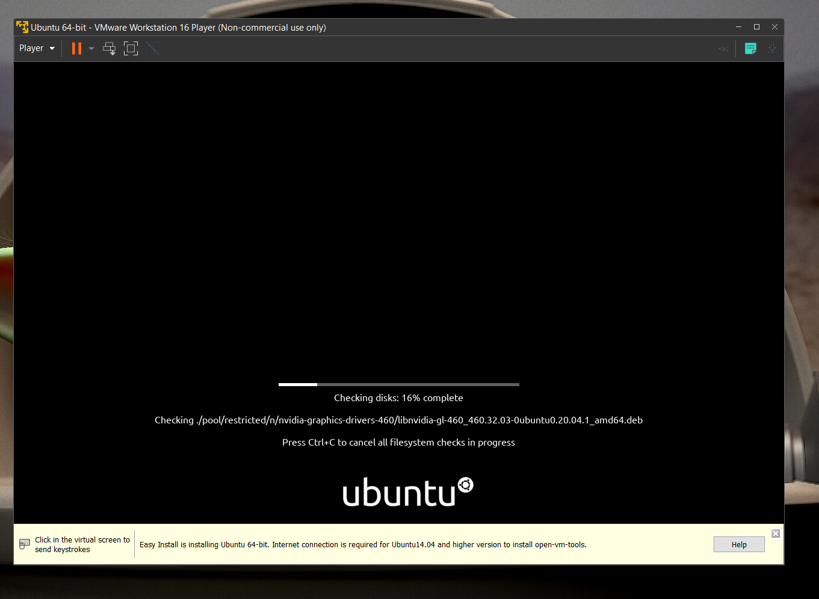

**INSTALLATION OF UBUNTU**

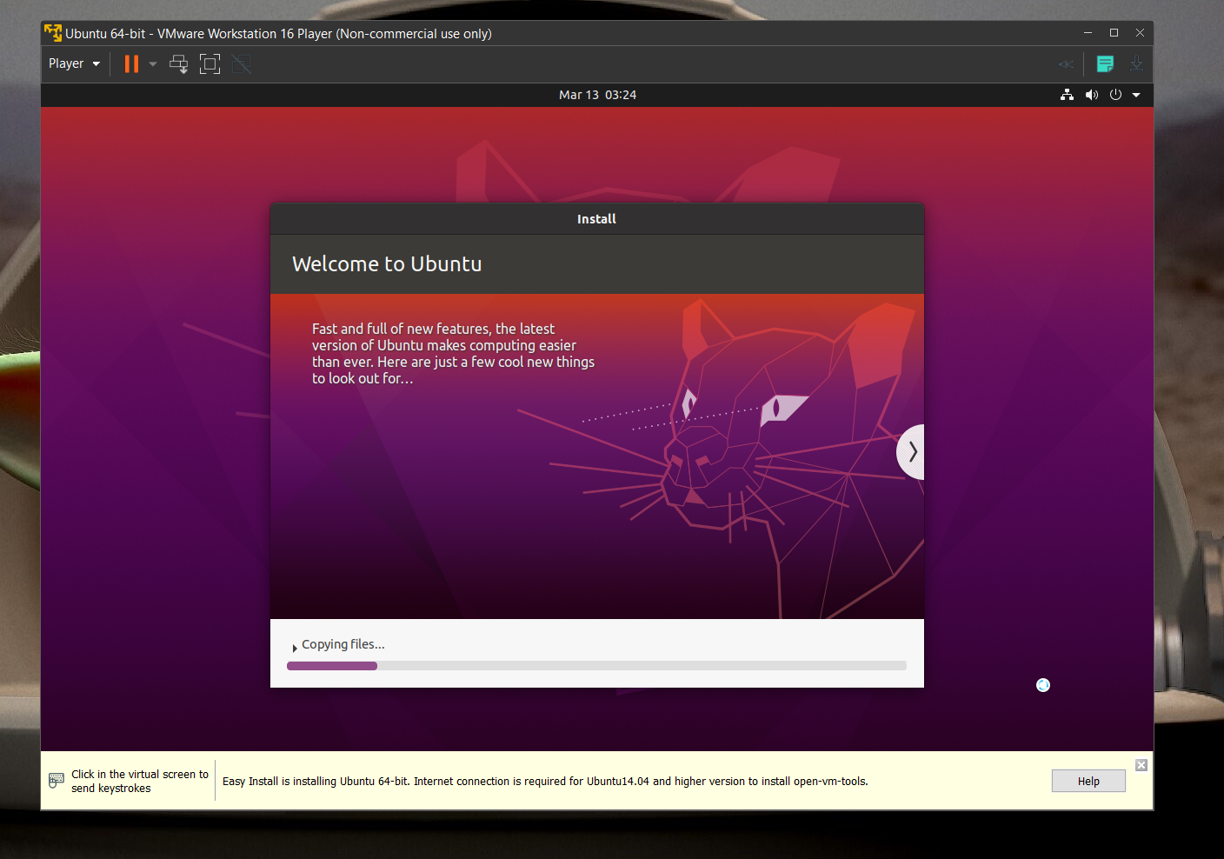

**Step 14: After installing, give password to Ubuntu startup and this is how its Root will look like.**

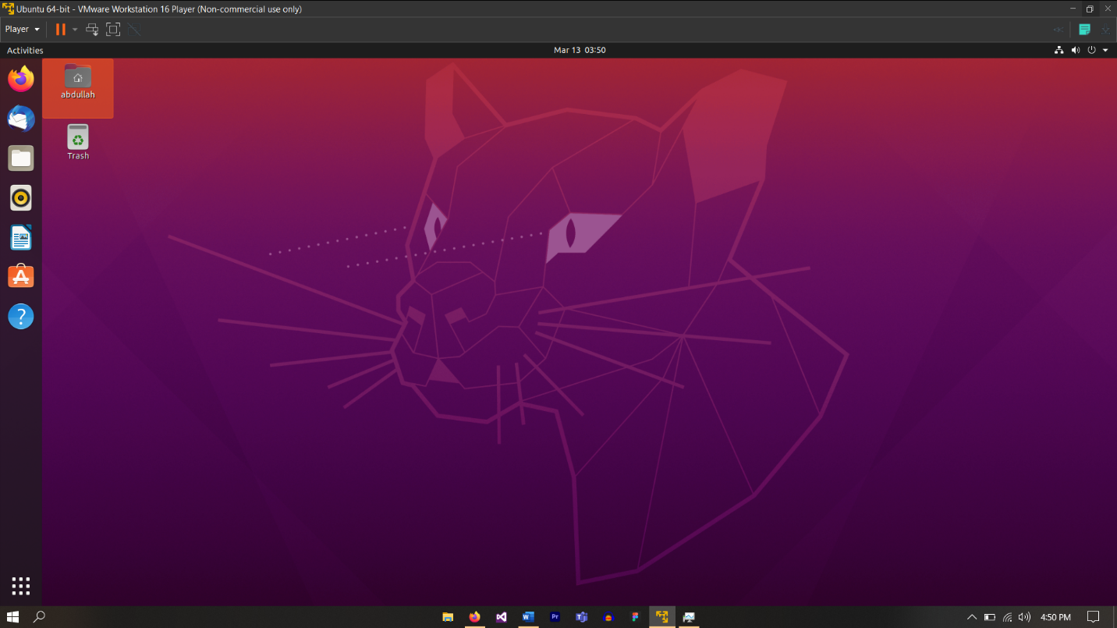

**HURRAH!**

**You have installed Ubuntu Successfully on VMware**

**TASK 2:**

**Installing and Running Code on C++ and C language**

**INSTALLING COMPILER FOR C++ AND C LANGUAGE**

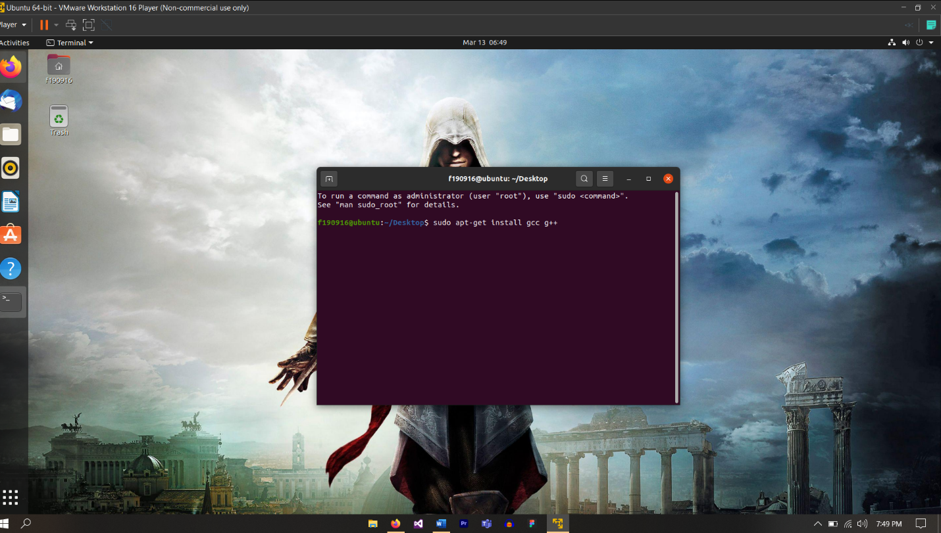

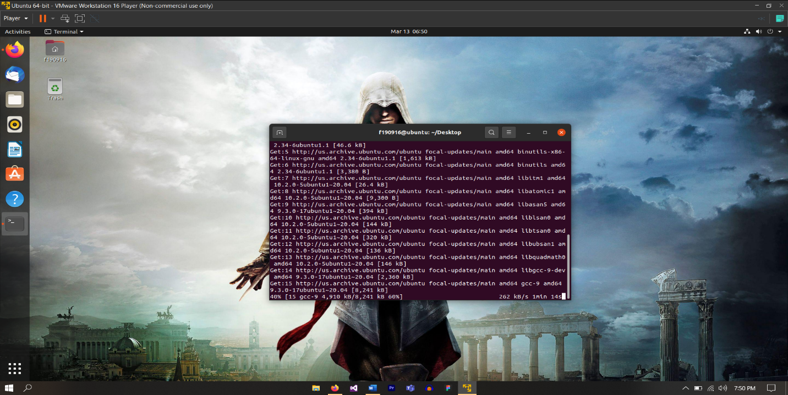

**COMPLING AND RUNNING C CODE IN UBUNTU**

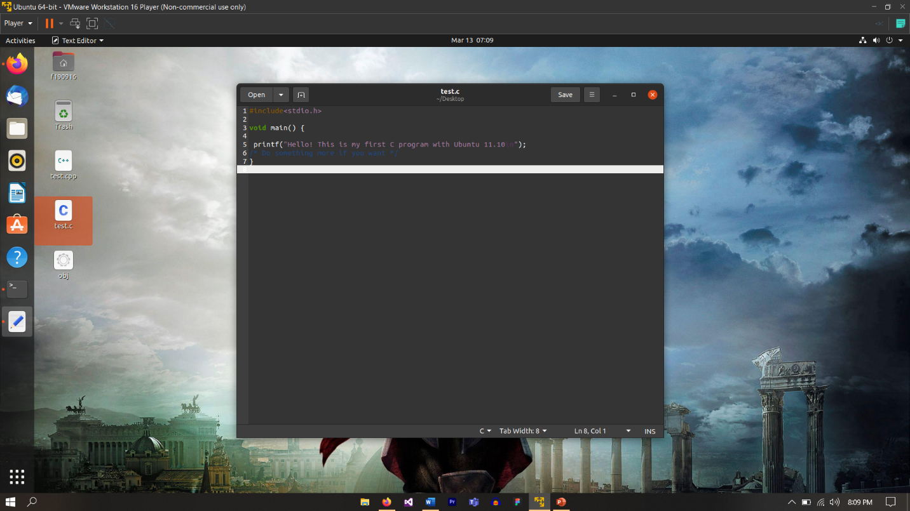

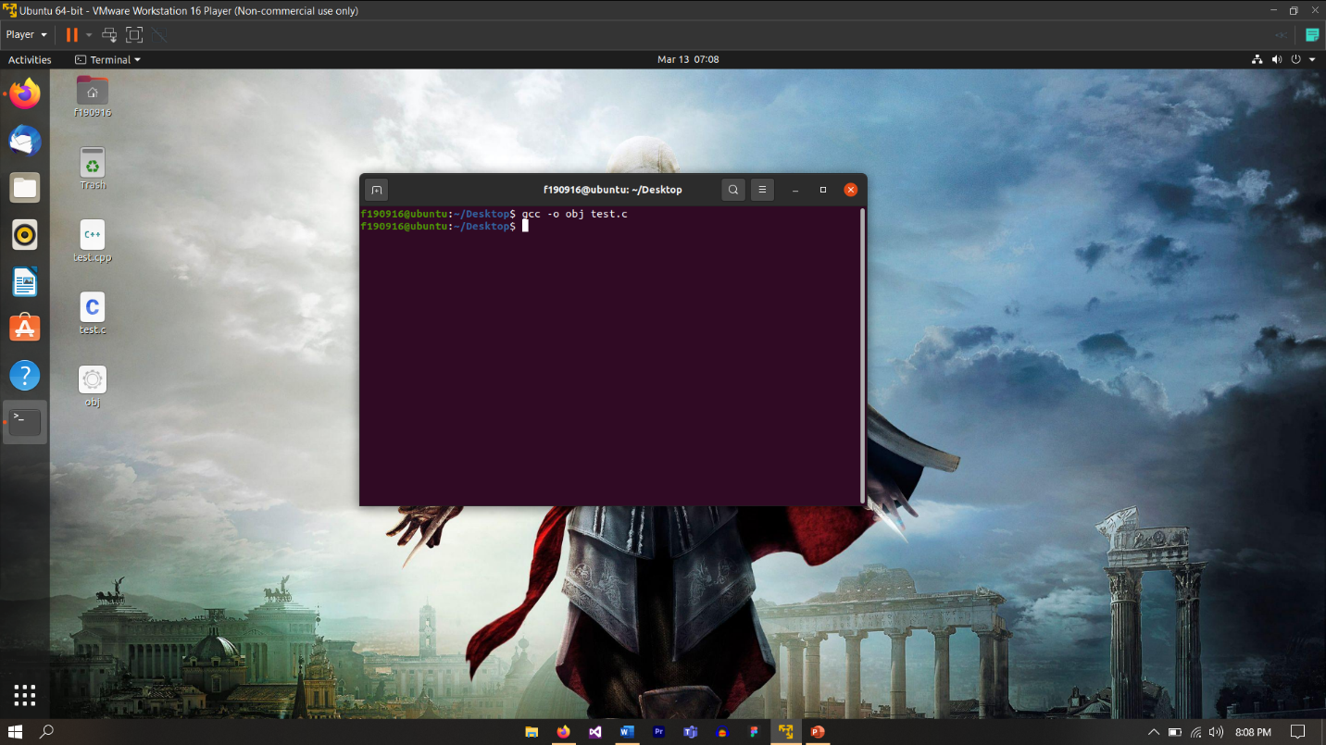

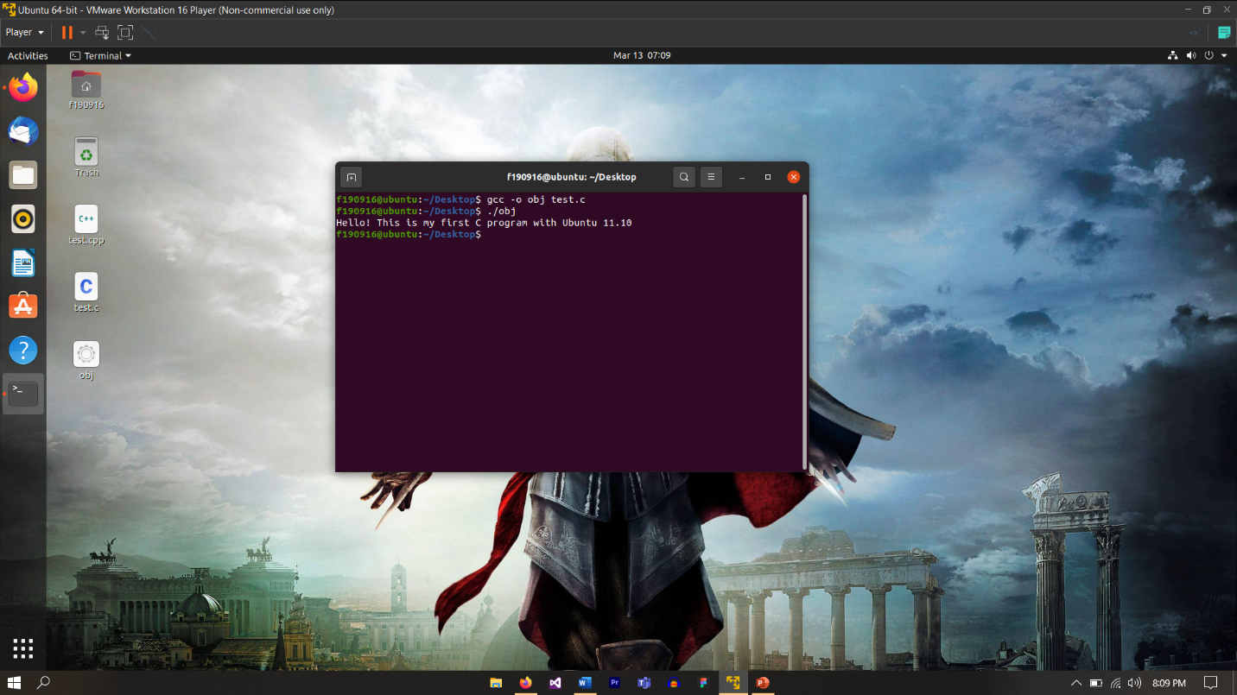

**COMPLING AND RUNNING C++ CODE IN UBUNTU**

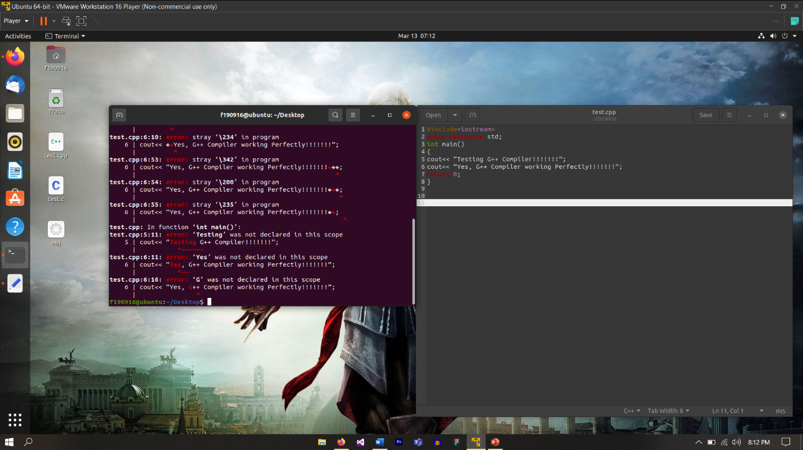

**ERROR IN COMPILING BUT EVERYTHING IS DONE CORRECTLY**